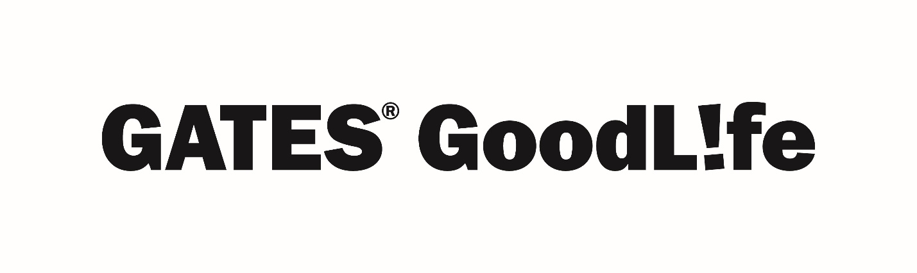GOODLIFE WELLBEING MONTHLY – AUGUST 2021 (SCALING DOWN FOR BETTER HEALTH)

Live Well Monthly Newsletter
Gates Benefits Highlights
Magellan Highlights: September is Suicide Prevention Awareness Month, which means that now may be a good time to check in with yourself and your loved ones, and prioritize your mental health. Spend a few minutes looking at the resources that Magellan has with their SPEAK Campaign. Speaking out about suicidal thoughts can be both overwhelming and frightening and knowing how to start a conversation can be difficult. During Suicide Prevention Awareness Month, we would like to remind you that your program provides resources and services to help you and your household members.
SPEAK Resources
Five Steps for Suicide Prevention (English); Five Steps for Suicide Prevention (Spanish)
SPEAK Resources (English); SPEAK Resources (Spanish)
SPEAK Tips Sheet (English); SPEAK Tips Sheet (Spanish)
Lifestyle Coach and Counseling
Lifestyle Coaching: Resource Info
Personal Resiliency Program: Program Info
Friendly Health Reminders & Resources
Suicide Prevention Awareness Month – National Suicide Prevention Lifeline
- National Suicide Prevention Week – September 5-11
- Out of the Darkness Walk – Find a Walk Near You
National Yoga Month –Yoga – Benefits Beyond the Mat; 5 Easy Ways to Celebrate National Yoga Month
National Self Improvement Month – Self Improvement Ideas for Work; 50 Ways to Improve Yourself During Self Improvement Month

